5.2 Property Binding



This section will guide you to:

* Implement data binding

This guide has three subsections, namely:

5.2.1 Implementing string interpolation and property binding

5.2.2 Pushing the code to Github repositories

Create the project with name as

**ng new angular-app**

Routing 🡪 no

Styling 🡪 css

**Step 5.2.1:** Implementing string interpolation and property binding

* Create product model class using angular cli as **ng g class product**

export *class* Product {

*constructor*(public *imageUrl*:*string*,

        public *productName*:*string*,

        public *code*:*string*,

        public *available*:String,

        public *price*:*number*,

        public *rating*:*number*){

    }

}

* Create product component using angular cli as **ng g c products** using terminal ie vs code terminal or command prompt terminal.

import { Component } from '@angular/core';

import { Product } from '../product';

@Component({

  selector: 'app-products',

  templateUrl: './products.component.html',

  styleUrls: ['./products.component.css']

})

export *class* ProductsComponents {

   pageTitle: *string* = "Product List Page";

   imageWidth:*number* = 80;

   imageMargin:*number* = 10;

   showImage:*boolean* = false;

   products:*Array*<Product>=[

    new Product("https://i.pinimg.com/236x/d9/b9/49/d9b9490af419f70a300d4552d6d737af.jpg","Leaf Rake","GDN-0011","March 19, 2016",19.95,3.5),

    new Product("https://i.pinimg.com/236x/1c/46/9d/1c469d4c102b6aa7f89a8c1b7c7cc797.jpg","Garden Cart","GDN-0023","March 18, 2016",32.99,4.2),

    new Product("https://i.pinimg.com/236x/38/13/43/38134365cf2f9a2e4e21ae3b1c7aa158.jpg","Hammer","TBX-0048","March 21, 2016",8.9,4.8),

    new Product("https://i.pinimg.com/236x/0d/ae/ed/0daeedbf7a3c6e22a35623a695a8c31b.jpg","Saw","TBX-0022","March 15, 2016",11.55,3.7),

    new Product("https://i.pinimg.com/236x/43/e7/82/43e78206fa3c28e1bfc8f92ba349052d.jpg","Video Game Controller","GMG-0042","October 15, 2015",35.95,4.6),

  ]

}

* Add the following code in *products.component.html*.

<div>

<h1> Product List Page </h1>

<table class="table">

    <tr>

        <th><input type="button" value="Show Image"/></th>

        <th>Product</th>

        <th>Code</th>

        <th>Available</th>

        <th>Price</th>

        <th>Rating</th>

    </tr>

<tr *ngFor="*let* p of products">

    <td>

        <img

            [src]='p.imageUrl'

            [title]='p.productName'

            [alt]='p.productName'

            [style.width.px]='imageWidth'

            [style.margin.px]='imageMargin'/>

    </td>

    <td>{{p.productName}}</td>

    <td>{{p.code}}</td>

    <td>{{p.available}}</td>

    <td>{{p.price}}</td>

    <td>{{p.rating}}</td>

</tr>

</table>

<div>

</div>

Now we have to write product component selector in parent component template ie app.component.html page

<div>

  <app-products></app-products>

</div>

To add the bootstrap features for the project please add bootstrap url in index.html page

<!doctype html>

<html lang="en">

<head>

  <meta charset="utf-8">

  <title>AngularApp</title>

  <base href="/">

  <meta name="viewport" content="width=device-width, initial-scale=1">

  <link rel="icon" type="image/x-icon" href="favicon.ico">

  <link href="https://cdn.jsdelivr.net/npm/bootstrap@5.0.2/dist/css/bootstrap.min.css"

  rel="stylesheet" integrity="sha384-EVSTQN3/azprG1Anm3QDgpJLIm9Nao0Yz1ztcQTwFspd3yD65VohhpuuCOmLASjC" crossorigin="anonymous">

</head>

<body>

  <app-root></app-root>

</body>

</html>

**Output:**

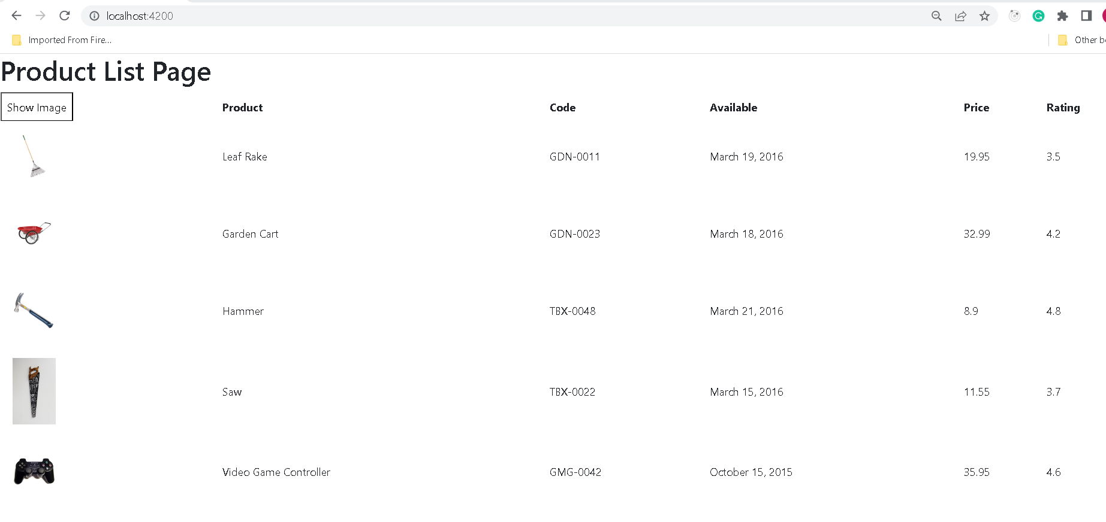

**Step 5.2.2:** Pushing the code to your GitHub repositories

Open your command prompt and navigate to the folder where you have created your files

cd <folder path>

Initialize your repository using the following command:

git init

Add all the files to your git repository using the following command:

git add .

Commit the changes using the following command:

git commit . -m “Changes have been committed.”

Push the files to the folder you initially created using the following command:

git push -u origin master